**Assignment 20.1**

**Problem Statement:**

Task9: Enhance the MapReduce program of Task 8 (refer session 19, assignment 3) to use multiple reducers for sorting. The driver should accept three additional values: the minimum units sold, the maximum units sold and number of reducers to use. Use units sold as key and company as value. Write a custom partitioner to divide the keys on the basis of range. Take minimum to be 0 and maximum to be 10. Divide them across 2 reducers.

**Input:**

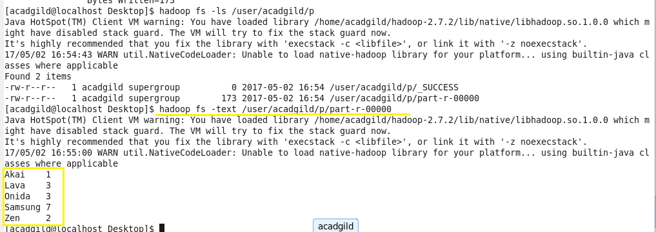

**Program:**

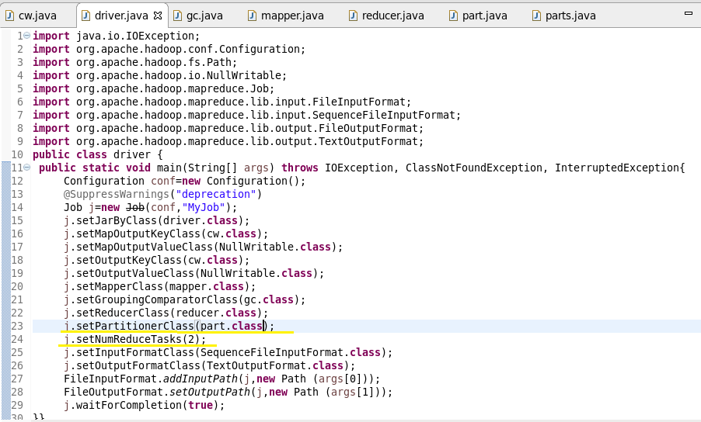

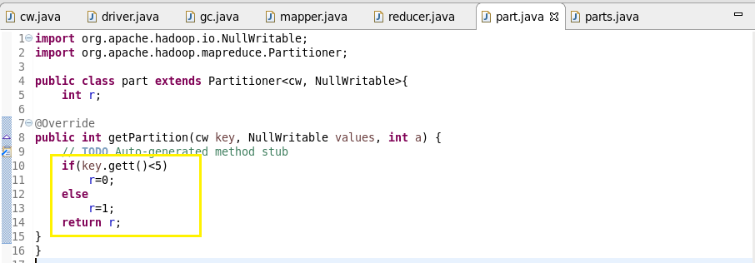

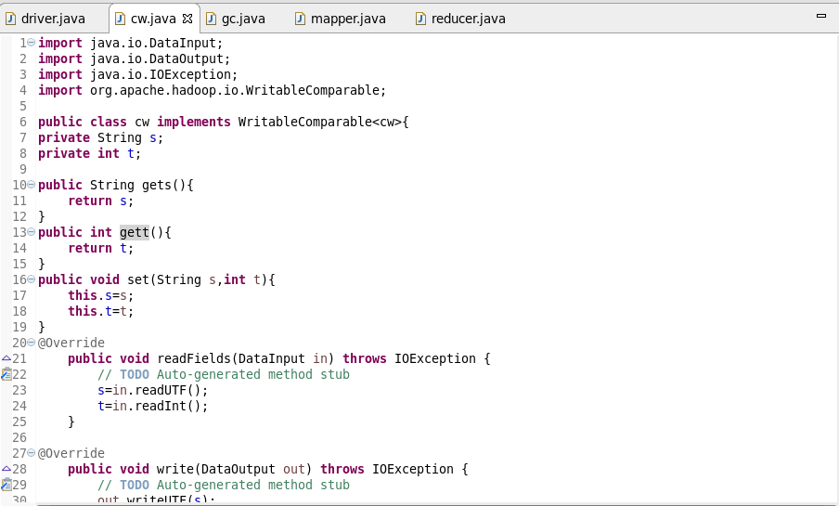

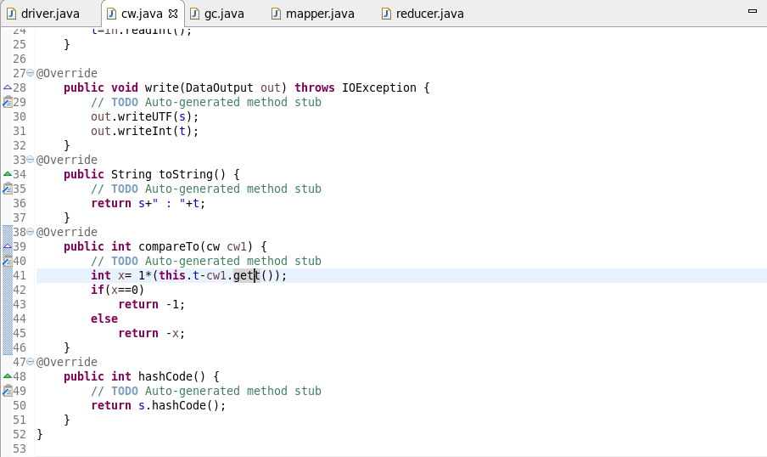

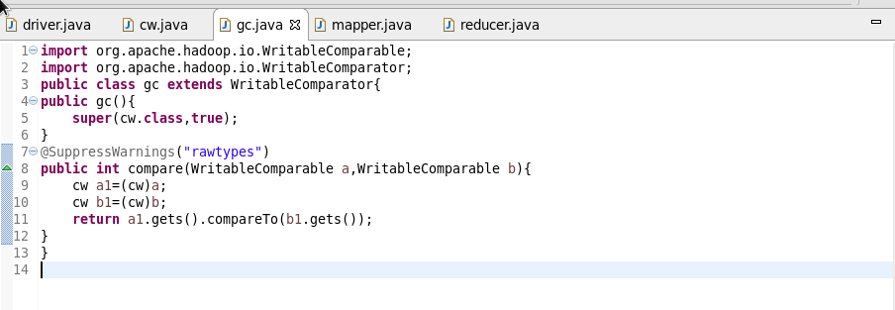

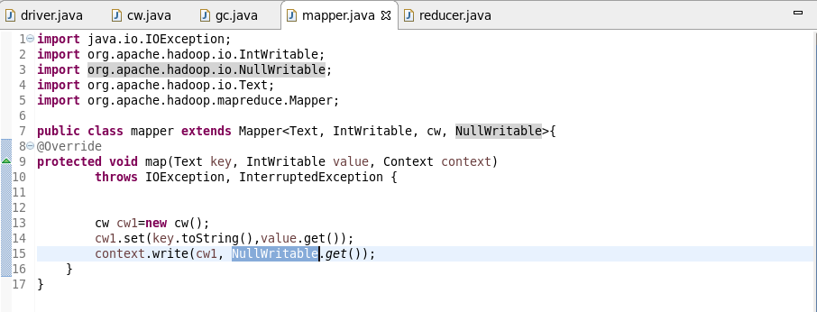

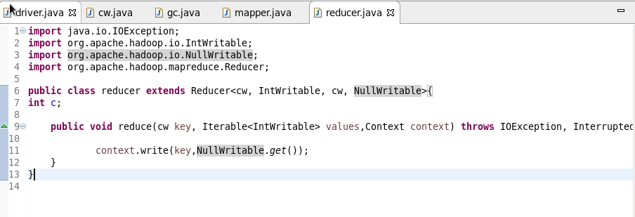

**Output:**



